GENERATIVE AI -PART 2

TABLE OF INDEX
Index | Title | Page
1 | Explain key models: GPT, DALL.E, Codex, Stable Diffusion | 2-5
2 | What is GAN and Diffusion model? | 6-8
3 | What are Transformers? | 9-14
4 | Applications in Enterprise AI | 15-16

- Explain key models: GPT, DALL.E, Codex, Stable Diffusion

These four foundational AI models represent different breakthroughs in generative artificial intelligence across text, images, and code generation.
- GPT:
A family of Large Language Models (LLMs) developed by OpenAI that use a transformer architecture to process and generate human-like text.
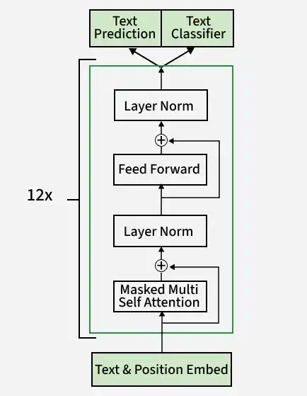
It relies on tokenization, embeddings, and self-attention mechanisms to predict the most likely next word or token in a sequence based on vast training data.Chatbots (like ChatGPT), essay writing, text summarization, language translation, and general reasoning tasks.

- DALL.E:
A text-to-image foundation model created by OpenAI that turns natural language descriptions into digital images.
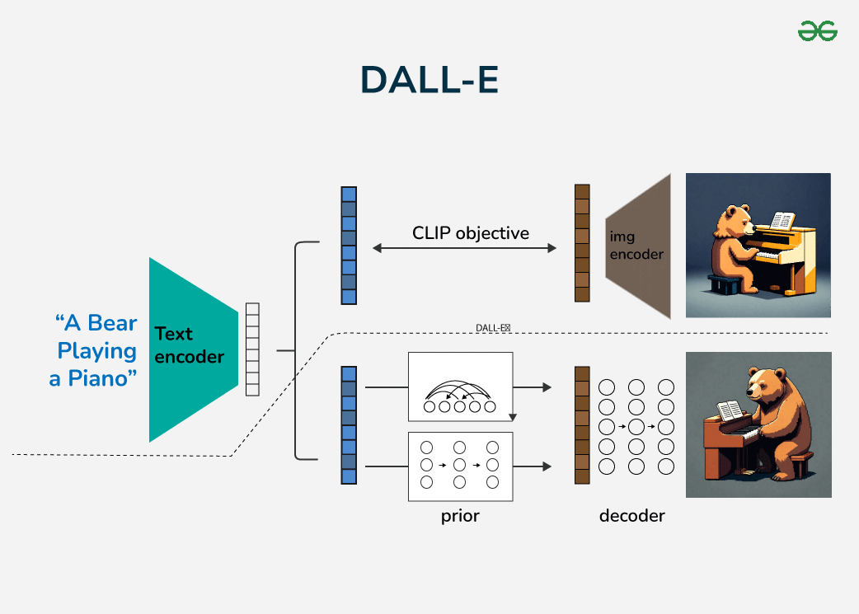
Early versions combined a Discrete Variational Autoencoder (dVAE) with a transformer, while modern iterations (like DALL-E 3) use deep neural networks integrated with language models like ChatGPT to map semantic concepts directly to visual pixels. Concept art, digital illustration, creative asset design, and inpainting (editing specific parts of an image via prompt).

- Codex:
Originally introduced as a specialized code-generation model trained on billions of lines of public code, Codex has evolved into an agentic AI coding platform by OpenAI that writes, debugs, and runs software.
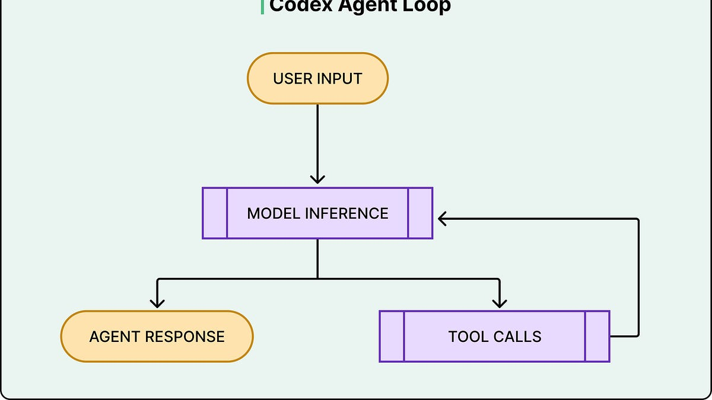
It translates plain-language English instructions into executable code across dozens of programming languages and operates inside isolated cloud sandboxes to run tests and construct pull requests. Automated bug fixing, code refactoring, full application scaffolding, unit test generation, and automated GitHub pull-request reviews.

- Stable Diffusion
An open-source, latent text-to-image diffusion model originally released by Stability AI, Runway, and CompVis.

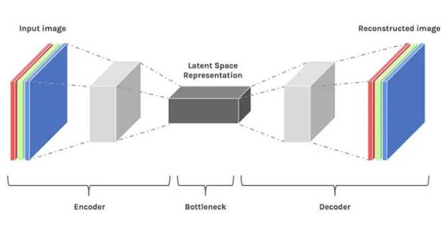

Unlike older generative adversarial networks (GANs), it starts with random visual noise and uses an iterative denoising process guided by a text prompt to gradually reveal a coherent image. Local AI art generation, custom fine-tuning on personal datasets, video generation tools, and commercial graphic design.

- What is Diffusion and GAN model?

- Diffusion Model:
Diffusion models are a class of generative artificial intelligence models that create realistic data (such as images, audio, and video) by learning to reverse a gradual noising process.

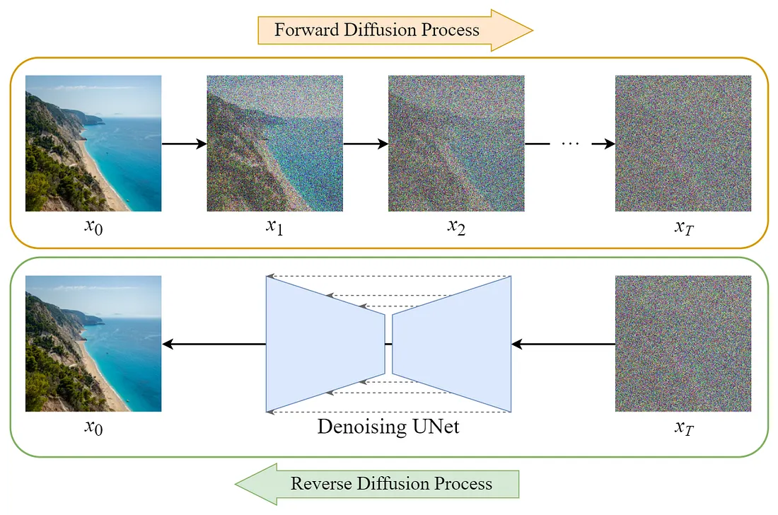

How They Work
- Forward Diffusion Process (Noising): The model takes structured real data and slowly destroys it by adding random Gaussian noise over many discrete timesteps until it turns into pure static.
- Reverse Diffusion Process (Denoising): A neural network—typically a U-Net or a transformer-based architecture—is trained to predict and remove the added noise step by step, recovering a clean, realistic sample from random noise.
- Conditioning (Guidance): Models use text prompts, class labels, or other signals via cross-attention and classifier-free guidance to direct the generation process toward a specific user request.
- Latent Diffusion: Instead of operating directly on high-resolution pixels, many modern frameworks like Stable Diffusion compress images into a smaller latent space to reduce computational costs.

Key Examples
- Image Generation & Editing: Stability AI's Stable Diffusion, OpenAI's DALL-E series, and Midjourney.
- Video & Audio Synthesis: Text-to-video and audio generation platforms.
- Scientific & Medical Applications: Protein structure prediction (such as AlphaFold) and medical image denoising for early diagnosis

- GAN MODEL:
A Generative Adversarial Network (GAN) is a machine learning framework where two neural networks compete against each other to create realistic synthetic data.
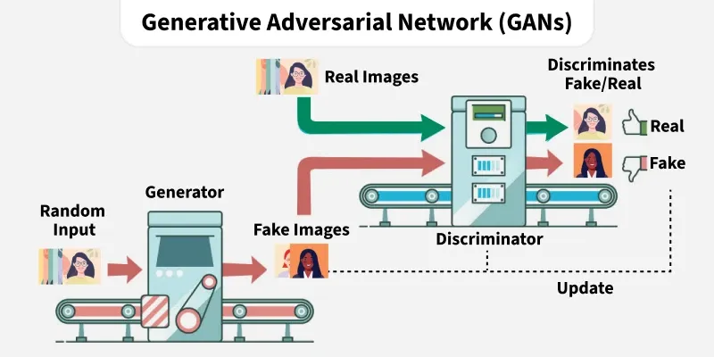

How a GAN Works
- The Generator: Takes random noise as input and creates fake data—such as images, audio, or text—that mimics real-world examples.
- The Discriminator: Acts as a binary classifier that receives both real data and fake data from the generator, trying to tell them apart.
- The Adversarial Process: The two networks train together in a zero-sum game. The generator tries to fool the discriminator, while the discriminator works to get better at spotting fakes. Over time, the generator produces data so authentic that the discriminator can no longer tell the difference.
Core Components
- Introduced by: Ian Goodfellow and his colleagues in 2014.
- Loss Function: Uses a minimax game where the generator minimizes its chance of detection while the discriminator maximizes its classification accuracy.
- Common Challenges: Training can be unstable, and models can suffer from mode collapse (where the generator produces only a limited variety of repetitive outputs).
Popular GAN Variants
- DCGAN (Deep Convolutional GAN): Uses convolutional layers for stable, high-quality image generation.
- CGAN (Conditional GAN): Adds labels or extra conditions to guide what kind of data the model generates.
- CycleGAN: Translates images from one domain to another without needing paired training data (e.g., turning a photo of a horse into a zebra).
- StyleGAN: Generates ultra-realistic human faces and high-resolution images with fine control over style.
- WGAN (Wasserstein GAN): Improves training stability by modifying the loss function to fix vanishing gradients.

- What are Transformers?

A transformer model is a deep learning neural network architecture that processes sequential data in parallel and uses self-attention to understand context and relationships across entire data sequences at once .
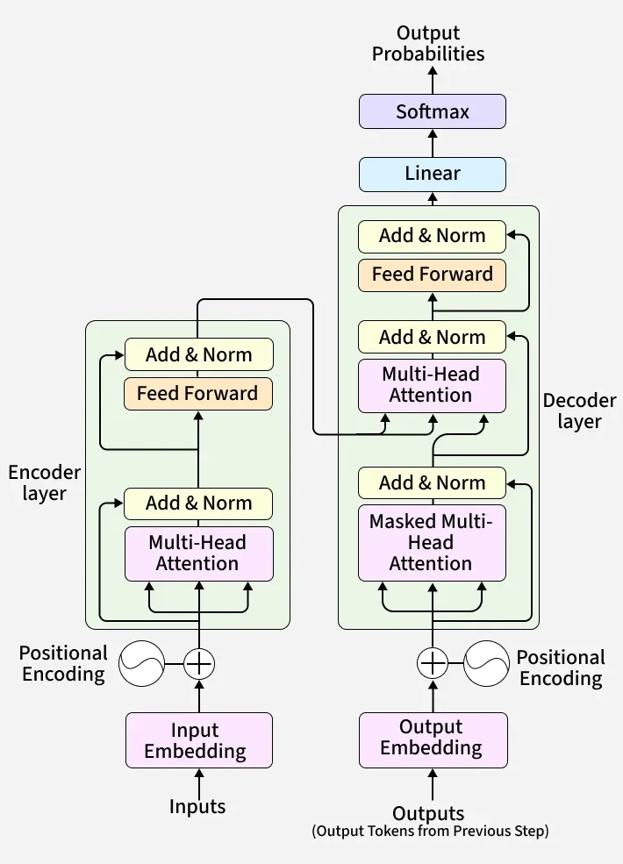

Self Attention Mechanism
The self attention mechanism allows transformers to determine which words in a sentence are most relevant to each other. This is done using a scaled dot-product attention approach
Each word in a sequence is mapped to three vectors:
- Query (Q)
- Key (K)
- Value (V)
These scores determine how much attention each word should pay to others.

Multi-Head Attention
Instead of one attention mechanism, transformers use multiple attention heads running in parallel. Each head captures different relationships or patterns in the data, enriching the model’s understanding.

Positional Encoding
Unlike RNNs, transformers lack an inherent understanding of word order since they process data in parallel. To solve this problem Positional Encodings are added to token embeddings providing information about the position of each token within a sequence.

Position-wise Feed-Forward Networks
The Feed-Forward Networks consist of two linear transformations with a ReLU activation. It is applied independently to each position in the sequence.This transformation helps refine the encoded representation at each position.
Mathematically:
FFN(x)=ReLU(xW1+b1)W2+b2
FFN(x)=ReLU(x)

Add & Norm (Residual Connections and Layer Normalization)
Each sub-layer in the transformer (such as self-attention and feed-forward networks) is followed by an Add & Norm step.
- Residual Connection (Add): The input of a layer is added to its output. This helps in preserving information and prevents vanishing gradients in deep networks.
- Layer Normalization (Norm): The combined output is normalized to stabilize training and improve convergence.
This structure ensures better gradient flow and allows training of deep transformer models efficiently.

Embeddings
Transformers cannot work with raw words as they need numbers. So, each input token (word or subword) is converted into a vector, called an embedding.
- Both encoder input tokens and decoder input tokens are converted into embeddings.
- These embeddings are trainable, meaning the model learns the best numeric representation for each token.
- The same weight matrix is shared for Encoder embeddings, Decoder embeddings and the final linear layer before softmax
- The embeddings are scaled by model to keep values stable before adding positional encoding.

Encoder-Decoder Architecture
The encoder-decoder structure is key to transformer models. The encoder processes the input sequence into a vector, while the decoder converts this vector back into a sequence. Each encoder and decoder layer includes self-attention and feed-forward layers.
For example, a French sentence "Je suis étudiant" is translated into "I am a student" in English.
Transformers apply attention in three different places:
Encoder Self-Attention
- Q, K, V all come from the encoder’s previous layer.
- Every word can attend to every other word in the input.
- This helps the encoder understand full context (long-range meaning).
Decoder Self-Attention (Masked)
- Q, K, V all come from the decoder’s previous layer.
- Future tokens are masked (blocked), so each position only sees previous tokens.
- This keeps decoding auto-regressive i.e the model predicts one word at a time.
Encoder–Decoder Attention
- Queries come from the decoder.
- Keys and Values come from the encoder output.
- This lets the decoder look at important parts of the input sentence while generating output.
Together, these three attention types allow the transformer to read the entire input at once and then generate outputs step-by-step with full context.

Softmax Layer for Output Prediction
After the decoder processes the sequence, it must predict the next token.
- The decoder output is passed through a linear layer (whose weights are shared with embeddings).
- Then the softmax function converts these scores into probabilities.
- The token with the highest probability becomes the predicted next word.

Applications
- NLP Tasks: Transformers are used for machine translation, text summarization, named entity recognition and sentiment analysis.
- Speech Recognition: They process audio signals to convert speech into transcribed text.
- Computer Vision: Transformers are applied to image classification, object detection and image generation.

Limitations
- Require high computational power, making them expensive to train
- Consume large memory, especially for long sequences
- Need large datasets to perform well

- Applications in Enterprise AI

Enterprise AI applications integrate machine learning, natural language processing (NLP), computer vision, generative AI, and autonomous AI agents directly into core business systems like ERP, CRM, and supply chain platforms.

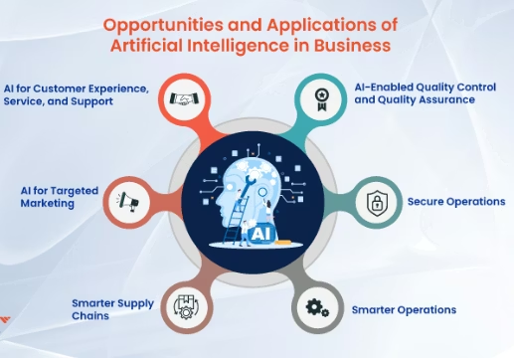

Key Enterprise AI Applications by Function
- Customer Service & Experience
  - Conversational AI & Chatbots: Virtual assistants handle real-time customer inquiries, sentiment analysis, and multi-turn problem-solving.
  - Personalization Engines: Deliver tailored product recommendations and dynamic pricing based on user behavior.
- Operations & Supply Chain
  - Predictive Maintenance: Analyze sensor data to anticipate equipment breakdowns and lower maintenance downtime.
  - Demand Forecasting & Inventory Optimization: Forecast market volatility, reduce stockouts, and manage logistics routing.
  - Quality Inspection: Use computer vision to automate defect detection on manufacturing lines
- Finance & Risk Management
  - Fraud & Anomaly Detection: Scan massive transaction volumes in real time to spot suspicious behavior.
  - Intelligent Document Processing (IDP): Extract data, parse contracts, and automate compliance or revenue reporting.

- IT Operations & Knowledge Work
  - AIOps & Infrastructure Monitoring: Predict system outages, monitor networks, and automate threat detection.
  - Enterprise Knowledge Assistants (RAG): Index internal company docs using Retrieval-Augmented Generation so employees can query institutional knowledge safely.
  - Agentic AI & Workflow Automation: Deploy autonomous AI agents that can reason, plan, and execute multi-step tasks across sandboxed enterprise environments.

